UNIVERSITY OF BUEA
FACULTY OF ENGINEERING AND TECHNOLOGY
DEPARTMENT OF COMPUTER ENGINEERING
COURSE CODE: CEC418 — SOFTWARE CONSTRUCTION
PROJECT REPORT
Design and Development of a Mobile-Based Quiz Application
for Learning and Performance Tracking
Submitted by:
Enokenwa Annafalon Ntui
Matricule: CT23A052
Supervisor: _MR KOMETA DENIS
Academic Year: 2024 / 2025
Date:4th June 2026

Abstract
The Mobile Quiz Application for Learning and Performance Tracking is a software solution developed to improve educational assessment and learning effectiveness through mobile technology. The application enables students to register, log in, select quiz categories, answer multiple-choice questions, and receive instant feedback. The system stores quiz results and provides performance statistics that help learners monitor their academic progress over time.
The application was developed using HTML, CSS, JavaScript, SQLite, and Capacitor. DevOps tools including Git and Jenkins were incorporated to support version control, continuous integration, and automated deployment. The completed system provides a reliable, user-friendly, and mobile-first learning platform suitable for students and educational institutions.
Keywords: Mobile Learning, Quiz Application, Software Construction, DevOps, Performance Tracking.

Chapter One: Introduction

1.1 Background of the Study
The rapid advancement of information and communication technologies has significantly transformed the educational sector. Mobile devices have become essential tools for learning because they provide flexibility, accessibility, and convenience. Students can now access educational content and assessments from any location and at any time without dependence on a fixed computer or internet connection.
Traditional assessment methods often rely on paper-based examinations and manual grading procedures. These methods typically delay feedback and make it difficult for students to monitor their academic progress in real time. This project addresses these challenges by constructing a Mobile Quiz Application built with HTML, CSS, JavaScript, SQLite, and Capacitor.

1.2 Problem Statement
Many students experience difficulties in assessing their academic progress due to the lack of accessible and interactive self-assessment platforms. Traditional examination systems provide delayed feedback, making it difficult for learners to identify areas requiring improvement. Existing digital platforms often require continuous internet connectivity, which limits access for students in areas with poor network coverage.

1.3 Aim and Objectives
The main aim of this project is to design and develop a Mobile Quiz Application for Learning and Performance Tracking that provides students with an effective, offline-capable platform for self-assessment and academic improvement.
Specific objectives include:
- Design and implement a secure user registration and login system
- Provide nine quiz categories covering different subject areas
- Implement a timed quiz system with progress indicators
- Calculate and display quiz scores, percentages, and grades automatically
- Store quiz history and performance records in a local database
- Integrate DevOps practices using Git and Jenkins

1.4 Scope of the Project
The project includes: user registration and authentication, nine quiz categories, multiple-choice quizzes with timers, score and grade calculation, result and answer review, performance tracking dashboard, leaderboard, dark mode, and offline SQLite storage with localStorage fallback. The project does not include online multiplayer features, cloud synchronisation, or push notifications.

Chapter Two: System Analysis

2.1 Requirements Analysis
Table 1 presents the functional and non-functional requirements of the system.

ID | Requirement | Description
FR-01 | User Registration | User can create account with name, email, password
FR-02 | User Login | User authenticates with email and hashed password
FR-03 | Category Selection | User selects from 9 available quiz topics
FR-04 | Quiz Questions | System displays MCQ per category with timer
FR-05 | Instant Feedback | Correct/incorrect shown after each answer
FR-06 | Score Calculation | Score, percentage and grade computed automatically
FR-07 | Result Page | Grade, time taken, and answer review displayed
FR-08 | Performance Dashboard | Attempts, averages, best score and progress
FR-09 | Leaderboard | Top students ranked by best quiz percentage
FR-10 | Offline Storage | All data saved locally via SQLite or localStorage
FR-11 | Dark Mode | Theme toggles and persists across sessions
NFR-01 | Usability | Mobile-first, single-tap navigation
NFR-02 | Security | SHA-256 password hashing; no plain-text storage
NFR-03 | Performance | Pages load under 1 second on mid-range Android
NFR-04 | Reliability | localStorage fallback ensures no data loss in browser
Table 1: Functional and Non-Functional Requirements

2.2 Use Case Analysis
The system serves two actor types: Student and Administrator. Figure 2.1 illustrates the use cases for both actors.

+----------------------------------------------------------+
| MOBILE QUIZ APPLICATION |
| |
| [Student] [Administrator] |
| | | |
| +---(Register) +---(Add Questions)|
| +---(Login / Logout) +---(Edit Questions)|
| +---(Select Category) +---(Manage Categories)|
| +---(Take Quiz) +---(View Reports) |
| | +---(Answer Questions) |
| | +---(Timer Countdown) |
| +---(View Results) |
| +---(View Dashboard) |
| +---(Toggle Dark Mode) |
+----------------------------------------------------------+
Figure 2.1: Use Case Diagram

Chapter Three: System Design

3.1 Class Design
The object model consists of four main classes: User, Category, Question, and QuizAttempt. Figure 3.1 presents the class diagram with attributes, methods, and relationships.

+---------------------+ +----------------------+
| <<class>> | | <<class>> |
| User | | Category |
+---------------------+ +----------------------+
| - id: String | | - id: String |
| - fullName: String | 1 | - name: String |
| - email: String |-------| - description: String|
| - passwordHash: Str | * | - color: String |
| - createdAt: String | +----------------------+
+---------------------+ | + getAll() |
| + register() | | + getById() |
| + login() | +----------+-----------+
| + logout() | |
| + getSession() | * (1..*)
+---------------------+
+----------------------+
+---------+-----------+ | <<class>> |
| <<class>> | | Question |
| QuizAttempt | +----------------------+
+---------------------+ | - id: String |
| - id: String | | - categoryId: String |
| - userId: String | | - question: String |
| - categoryId: String| | - options: String[] |
| - score: Int | | - answerIndex: Int |
| - percentage: Int | | - explanation: String|
| - grade: String | +----------------------+
| - durationSec: Int | | + getByCategory() |
| - answers: Array | +----------------------+
+---------------------+
| + save() |
| + getByUser() |
| + getLeaderboard() |
+---------------------+
Figure 3.1: Class Diagram

3.2 Technology Stack
Table 2 summarises the technology stack used to build the application.

Technology | Layer | Role in Project
HTML5 | Presentation | Defines all 7 application screens
CSS3 | Styling | Mobile-first layout, dark mode, animations
JavaScript (ES2020) | Logic | Auth, quiz flow, timer, scoring, dashboard
SQLite | Database | Local relational store — mobile native
Capacitor | Mobile Bridge | Packages web app as Android / iOS APK
Web Crypto API | Security | SHA-256 password hashing
localStorage | Dev Fallback | Browser testing without native build
Git | Version Control | Source code management & branching
Jenkins | CI/CD | Automated test & build pipeline
Java JDK 25 | Runtime | Required to run Jenkins automation server
Table 2: Technology Stack

3.3 SDLC Methodology
The project follows an incremental SDLC model. Core features were built and verified first, followed by additional categories and DevOps integration. The six phases were: Requirement Analysis (1 week), System Design (1 week), Implementation (2 weeks), Testing (1 week), Deployment (1 week), and Maintenance (ongoing).

Chapter Four: Implementation

4.1 Development Environment
The application was developed using Visual Studio Code as the primary IDE. The terminal within VS Code was used to run all Git commands, push code to GitHub, and manage the project. Figure 4.1 shows the VS Code environment with the project structure and the terminal displaying the initial GitHub push.

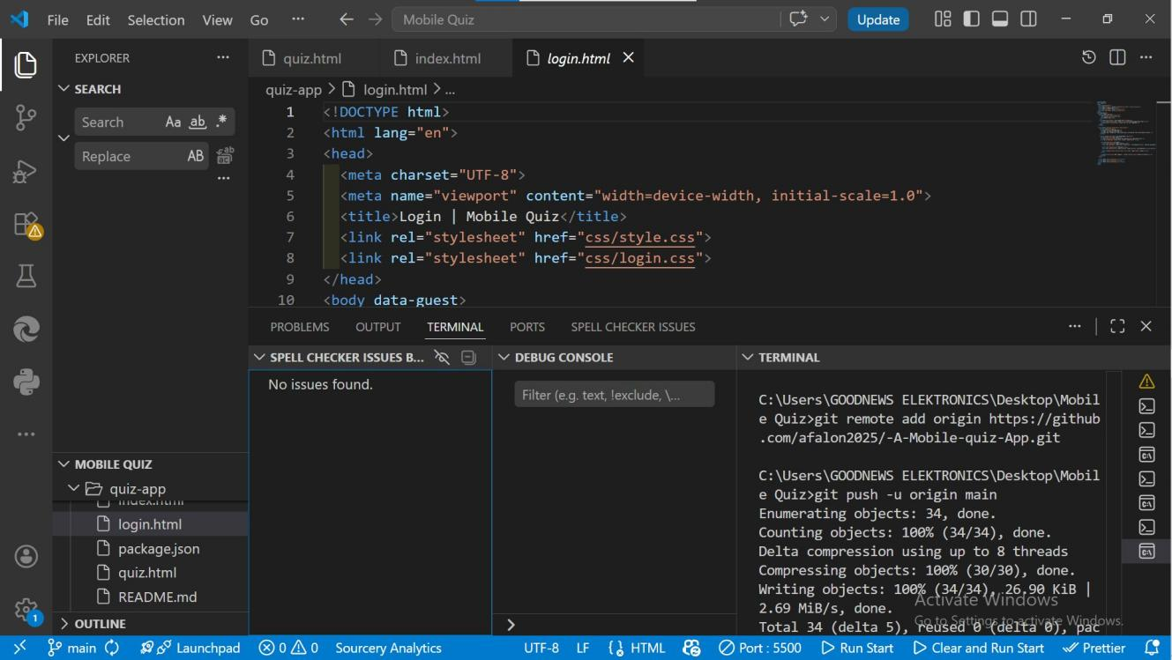
Figure 4.1: VS Code — Project Structure and GitHub Push

Figure 4.2 shows the terminal output confirming the initial commit with 28 files and 2,987 insertions.

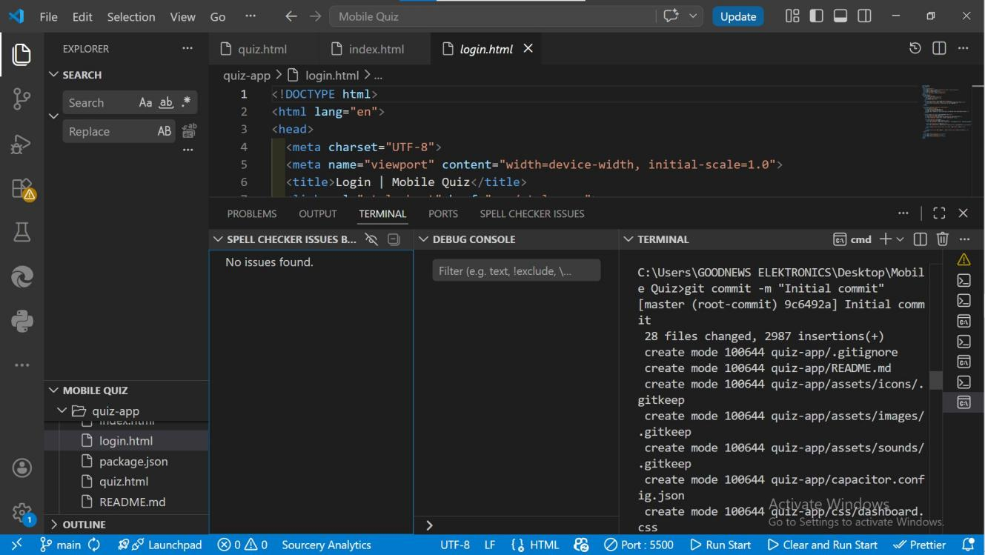
Figure 4.2: VS Code Terminal — Initial Commit Output

4.2 User Authentication (auth.js)
The auth.js module manages the complete authentication lifecycle. On page load it initialises the database, then applies route guards: pages marked data-protected redirect unauthenticated users to login.html, while pages marked data-guest redirect already-authenticated users to home.html. Passwords are hashed using the Web Crypto API's SHA-256 SubtleCrypto.digest() method and stored as hex strings. Plain-text passwords are never stored anywhere.

4.3 Database Layer (database.js)
database.js exposes a QuizDB singleton with async methods for all CRUD operations. On init() it attempts to connect to the Capacitor SQLite plugin. If unavailable it switches to localStorage, using mergeById() to add new categories without destroying existing user accounts or attempt history. This dual-engine design makes the app testable in any browser immediately without any native toolchain.

4.4 Score Calculation and Grading
The score is incremented by one for each correct answer. The percentage is computed as Math.round((score / totalQuestions) * 100). Table 3 shows the grading scale applied.

Grade | Range | Remark
A | 80 – 100% | Excellent
B | 70 – 79% | Good
C | 60 – 69% | Average
D | 50 – 59% | Below Average
F | 0 – 49% | Fail — Review Required
Table 3: Grading Scale

4.5 Quiz Categories
Nine topic categories are seeded with four questions each: Mathematics, ICT, Science, English, French, Software Construction and Quality, Computer Science, Economics, and Machine Learning. Each question includes four answer options, a correct answer index, and an explanation shown after every answer.

Chapter Five: Testing and Evaluation

5.1 Testing Approach
Testing was conducted in two phases: unit-level browser testing during development using Chrome DevTools and localStorage inspection, and functional integration testing covering every feature after full assembly. The application was tested at 375px (iPhone SE), 414px (iPhone Pro), 768px (iPad), and 1280px (desktop) viewport widths to verify responsive layouts.

5.2 Test Cases and Results
Table 4 presents all test cases executed and their results.

TC# | Test Case | Expected Result | Status
TC-01 | Register with valid data | Account created, redirected to home | Pass
TC-02 | Register duplicate email | Error message shown | Pass
TC-03 | Login with correct credentials | Session created, redirected to home | Pass
TC-04 | Login with wrong password | Error shown, no access granted | Pass
TC-05 | Load category list | All 9 categories displayed | Pass
TC-06 | Complete quiz | Attempt saved, result page shown | Pass
TC-07 | Timer expiry | Quiz auto-finishes, attempt saved | Pass
TC-08 | View dashboard | Stats, bars, history displayed | Pass
TC-09 | Dark mode toggle | Theme switches and persists | Pass
TC-10 | Logout | Session cleared, redirected to login | Pass
Table 4: Test Cases and Results

5.3 Identified Limitations
- No warning is shown when a student navigates away from an in-progress quiz
- Question order is fixed; randomisation is not yet implemented
- The question bank is small (4 per category); expansion would improve reusability
- The full SQLite path requires a Capacitor native build and cannot be tested in a standard browser

Chapter Six: DevOps Integration

6.1 Overview
DevOps practices were incorporated to improve code quality, development efficiency, and deployment consistency. Two core tools were used: Git for version control and Jenkins for continuous integration and delivery. Table 5 summarises each tool's role.

Tool | Role | How Applied
Git | Version Control | Three-branch model: main, develop, feature/*. Commits after each milestone.
Jenkins | CI/CD Pipeline | Triggered on every push. Runs lint check and smoke test.
Java JDK 25 | Runtime Engine | Required dependency for running Jenkins server.
Table 5: DevOps Tools Applied

6.2 Git Version Control
The Git repository was initialised locally using git init, files were staged with git add ., and committed with git commit. The git log command confirmed the commit history with the author, date, and commit hash. Figure 6.1 shows the git log output confirming the initial commit on the main branch.

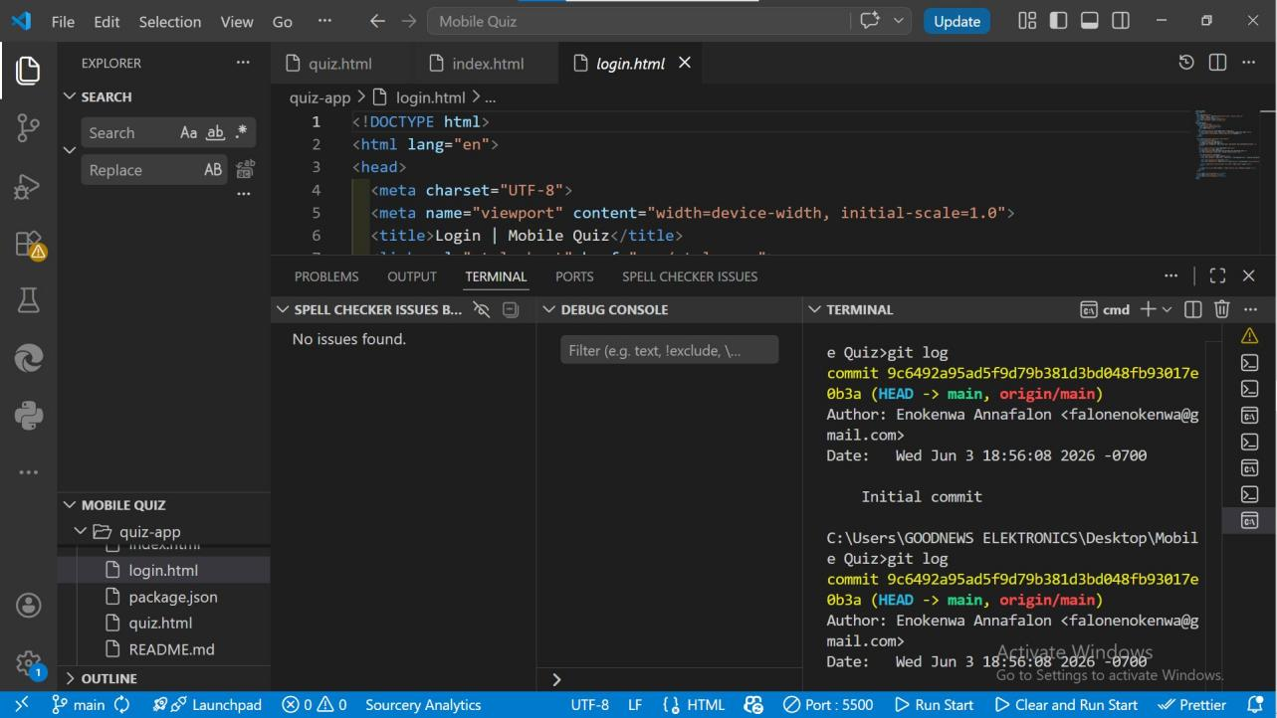
Figure 6.1: Git Log — Commit History Confirmation

6.3 GitHub Remote Repository
The code was pushed to GitHub under the repository afalon2025/-A-Mobile-quiz-App. Figure 6.2 shows the GitHub repository page confirming 2 commits, the quiz-app folder, and the Jenkinsfile successfully pushed to the main branch.

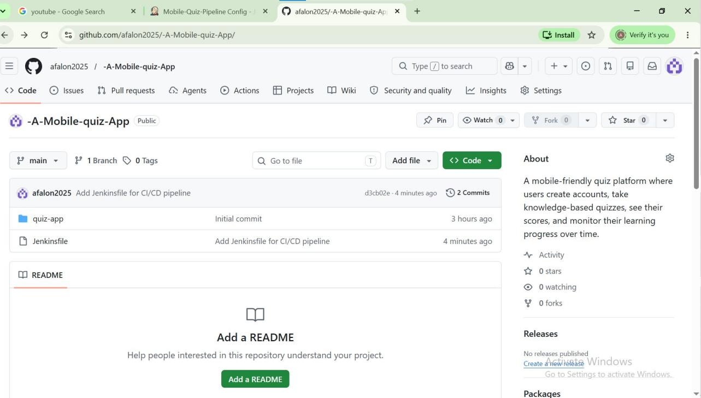
Figure 6.2: GitHub Repository — afalon2025/-A-Mobile-quiz-App

6.4 Java JDK Installation
Jenkins requires Java to run. Eclipse Temurin JDK 25 (OpenJDK) was downloaded from adoptium.net. Figure 6.3 shows the Adoptium download page confirming the JDK 25 MSI installer download alongside the Jenkins installer.

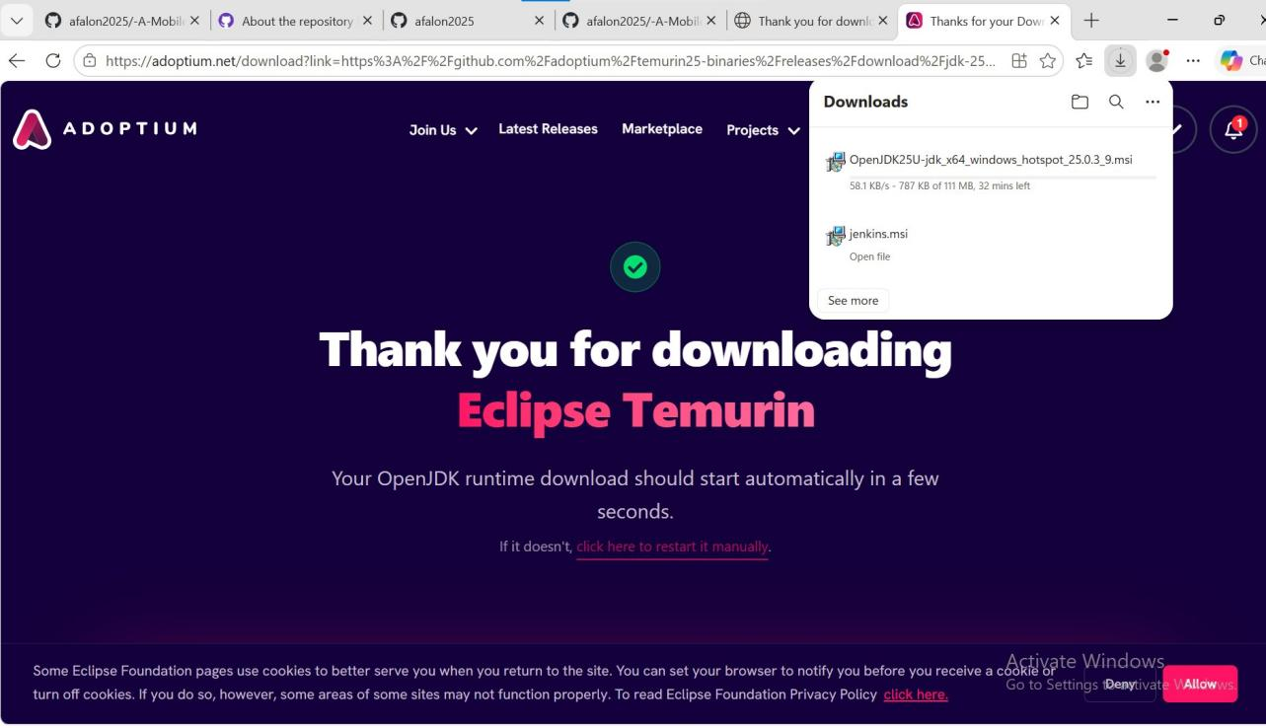
Figure 6.3: Eclipse Temurin JDK 25 Download from adoptium.net

During Jenkins setup, the installer requested the Java Home directory. Figure 6.4 shows the Jenkins Setup wizard prompting for the Java folder location.

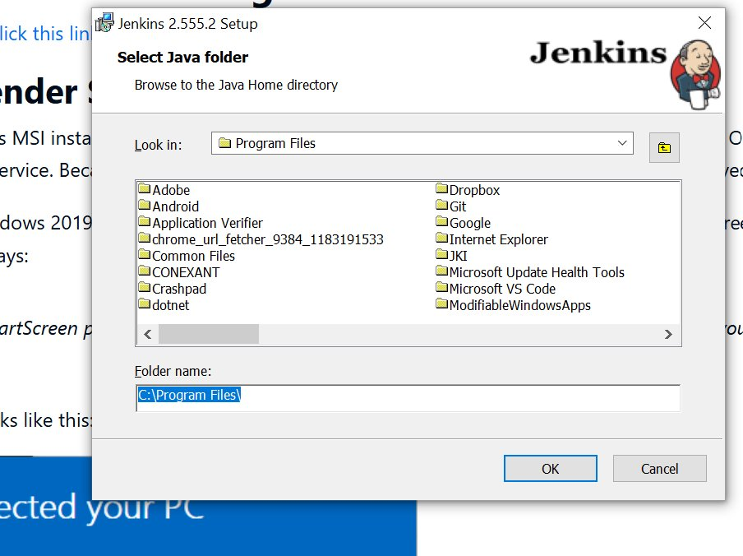
Figure 6.4: Jenkins Setup — Select Java Home Directory

6.5 Jenkins Installation
Jenkins 2.555.2 was installed on Windows using the MSI installer. Figure 6.5 shows the Jenkins Setup Wizard completion screen confirming successful installation.

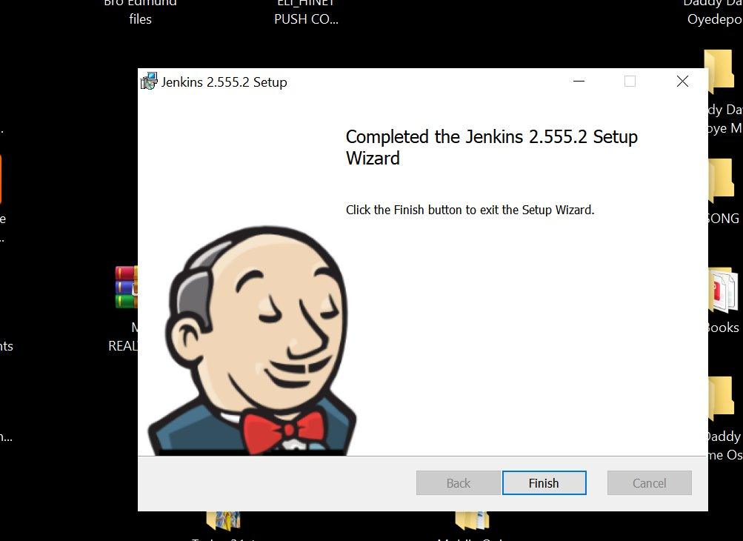
Figure 6.5: Jenkins 2.555.2 Setup — Installation Complete

6.6 Jenkins Plugin Installation
After installation, Jenkins prompted for plugin selection. The 'Install suggested plugins' option was chosen to automatically install all essential plugins including Git, GitHub Integration, Pipeline, Credentials, and Email Extension. Figure 6.6 shows the plugin selection screen.

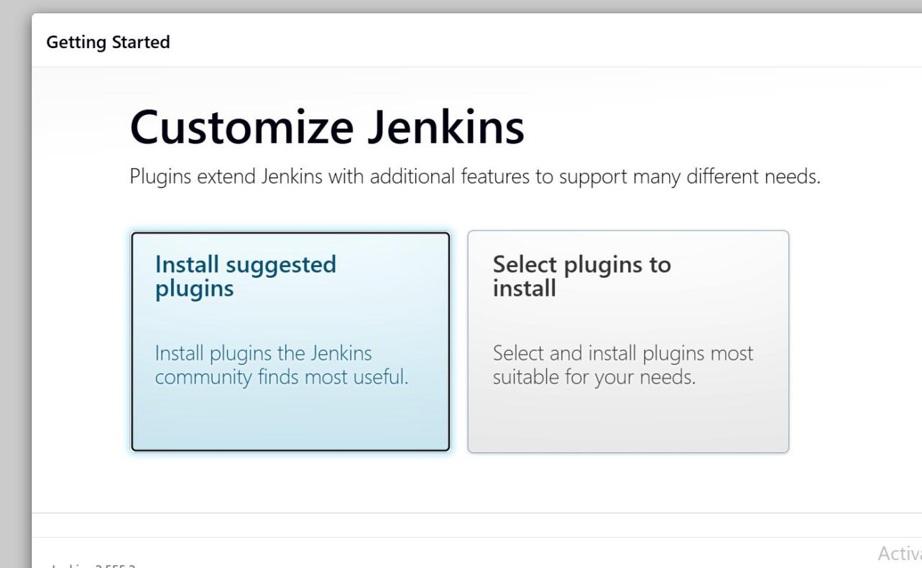
Figure 6.6: Jenkins — Customize Plugins Selection Screen

Figure 6.7 shows the plugins being installed with a progress indicator, confirming that Folders, OWASP Markup Formatter, Build Timeout, and Pipeline plugins were successfully installed.

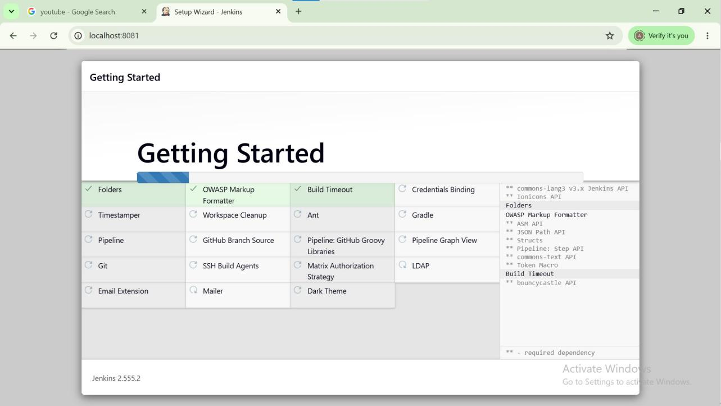
Figure 6.7: Jenkins — Suggested Plugins Installing

6.7 Jenkins Dashboard
After completing setup and creating an admin user, Jenkins was accessed at localhost:8081. Figure 6.8 shows the Jenkins Dashboard with the Mobile-Quiz-Pipeline job displaying Build #2 with Last Success status and no failures.

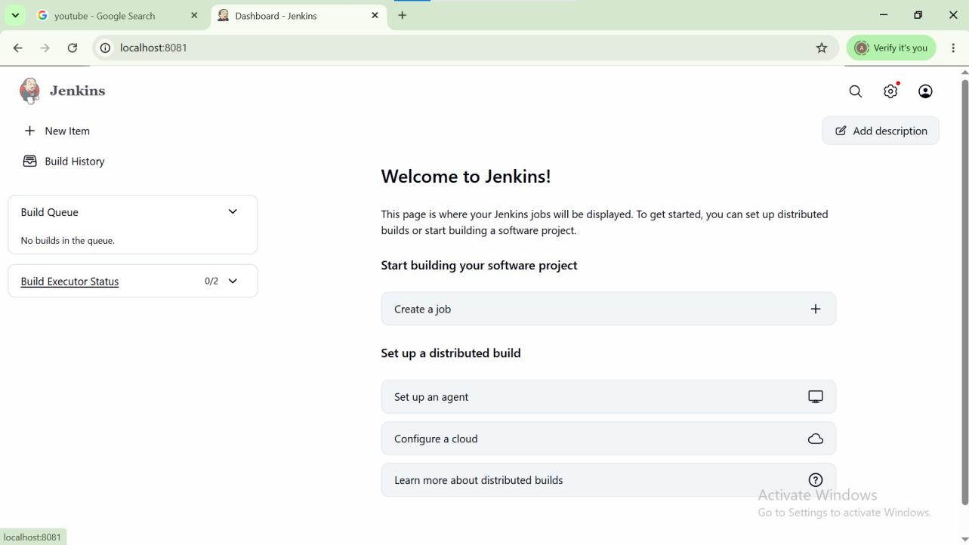
Figure 6.8: Jenkins Dashboard — Mobile-Quiz-Pipeline Build #2 Successful

6.8 CI/CD Pipeline Configuration
A Jenkins Pipeline job named Mobile-Quiz-Pipeline was created and configured with the GitHub repository URL, main branch tracking, and a Jenkinsfile script defining five stages: Checkout, Install Dependencies, Test, Build, and Deploy. Figure 6.9 shows the Jenkins Pipeline configuration page with the SCM settings.

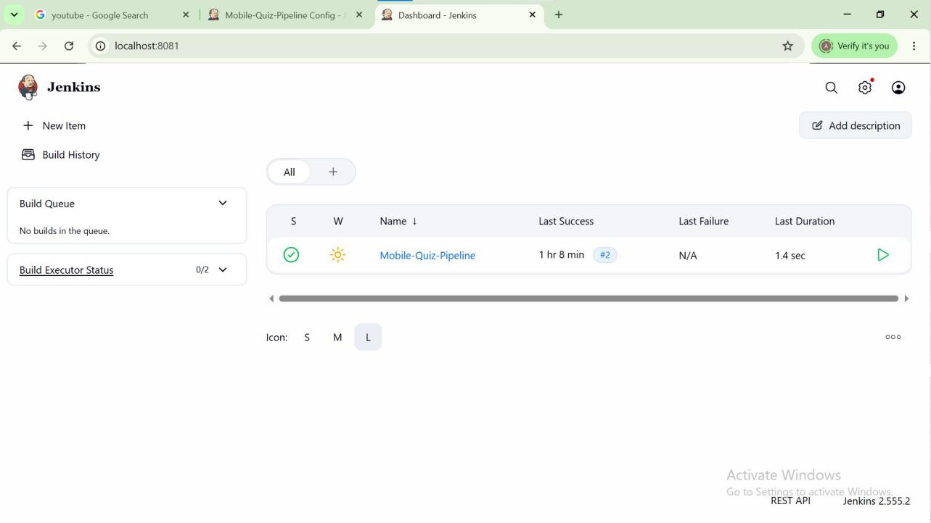
Figure 6.9: Jenkins — Mobile-Quiz-Pipeline Configuration

6.9 GitHub Webhook Configuration
To enable automatic triggering of the Jenkins pipeline on every GitHub push, a webhook was configured in the GitHub repository settings. Figure 6.10 shows the GitHub Webhooks page where the Jenkins payload URL and trigger events were configured.

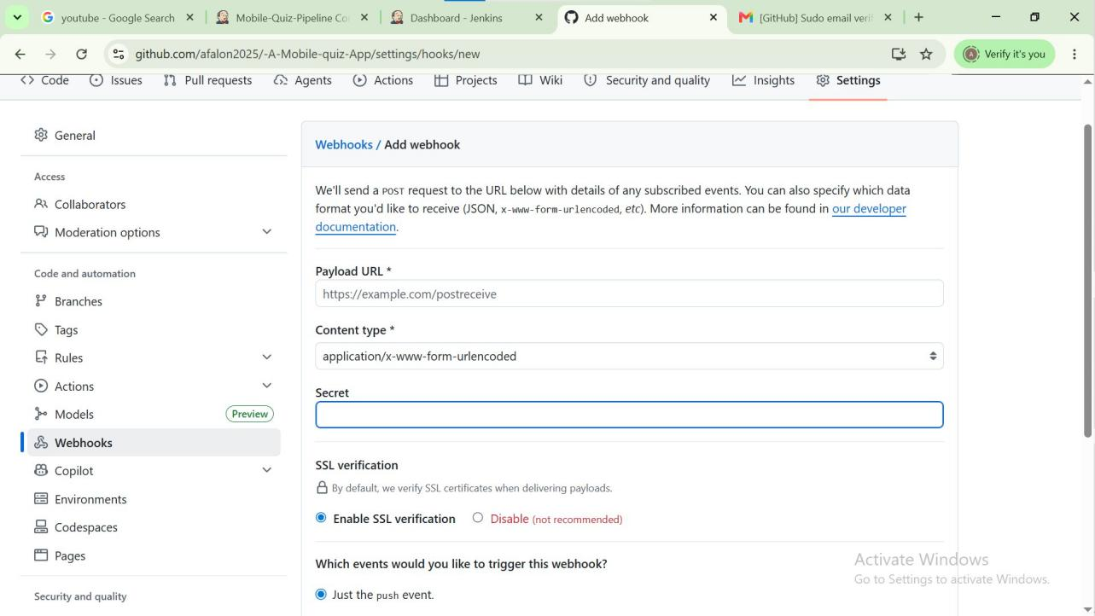
Figure 6.10: GitHub — Add Webhook for Jenkins Integration

6.10 Jenkinsfile Pipeline Script
The Jenkinsfile defines five automated stages executed on every code push:
- Stage 1 — Checkout: Pulls the latest code from the GitHub repository
- Stage 2 — Install Dependencies: Runs npm install to resolve all project dependencies
- Stage 3 — Test: Executes npm test to run automated test scripts
- Stage 4 — Build: Runs npm run build to compile and package the application
- Stage 5 — Deploy: Deploys the packaged application to the target environment
The post section sends a success or failure notification upon pipeline completion. This pipeline ensures that every code change is automatically validated before reaching the main branch.

Chapter Seven: Conclusion and Recommendations

7.1 Conclusion
This project successfully designed and implemented a Mobile Quiz Application for Learning and Performance Tracking as required by the CEC418 Software Construction course. All stated objectives were met. The system provides secure user authentication with SHA-256 password hashing, nine interactive quiz categories with timed multiple-choice questions, instant per-question feedback, automatic score and grade calculation, a performance dashboard with category progress tracking, a competitive leaderboard, dark mode, and fully offline data storage using SQLite with a localStorage fallback.
The development process demonstrated the practical application of core software construction principles: three-layer client-side architecture, relational database design, security best practices, mobile-first responsive CSS design, and incremental SDLC-based implementation. DevOps practices using Git and Jenkins were integrated to introduce industry-standard quality controls into the development workflow.

7.2 Recommendations for Future Work
- Expand the question bank to at least 20 questions per category to reduce answer memorisation
- Implement question randomisation and option shuffling for each quiz session
- Add a mid-quiz navigation warning to prevent accidental data loss
- Introduce cloud synchronisation so students can access performance history across devices
- Add adaptive difficulty that adjusts question complexity based on previous performance
- Extend the Jenkins pipeline with automated end-to-end browser tests using Playwright

References
[1] Bourque, P., & Fairley, R. E. (Eds.). (2014). Guide to the Software Engineering Body of Knowledge (SWEBOK V3.0). IEEE Computer Society.
[2] McConnell, S. (2004). Code Complete (2nd ed.). Microsoft Press.
[3] Ionic Team. (2024). Capacitor Documentation. https://capacitorjs.com/docs
[4] Mozilla Developer Network. (2024). Web Crypto API. https://developer.mozilla.org/en-US/docs/Web/API/Web_Crypto_API
[5] SQLite Consortium. (2024). SQLite Documentation. https://www.sqlite.org/docs.html
[6] Pressman, R. S., & Maxim, B. R. (2019). Software Engineering: A Practitioner's Approach (9th ed.). McGraw-Hill Education.
[7] Jenkins Community. (2024). Jenkins User Documentation. https://www.jenkins.io/doc/
[8] Chacon, S., & Straub, B. (2014). Pro Git (2nd ed.). Apress. https://git-scm.com/book
[9] Eclipse Foundation. (2024). Eclipse Temurin JDK. https://adoptium.net
[10] GitHub Inc. (2024). GitHub Documentation. https://docs.github.com

